Triggered LFP Client:

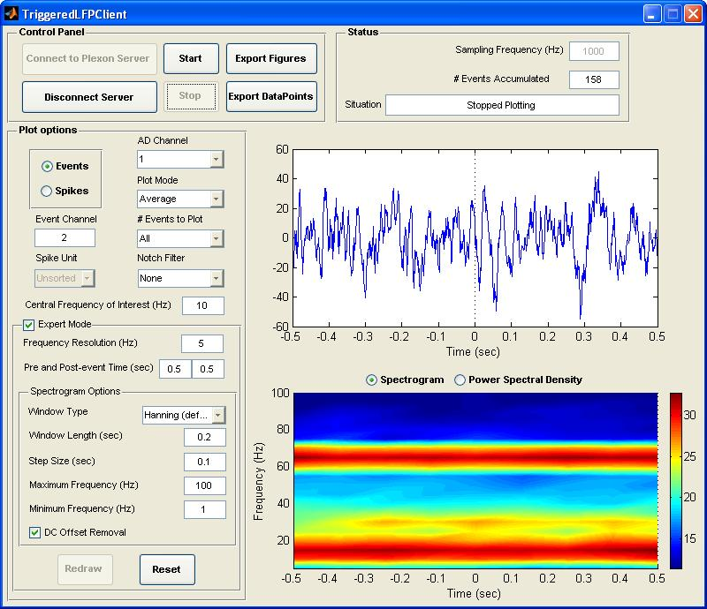

Control Panel

- Connect to Plexon Server
This push button makes a connection between the software and the Plexon server and gets the required information such as active AD channels, sampling frequency of each channel from the server.
- Disconnect Server
It disconnects the software from the server. When it is disconnected some parameters can be changed while the control panel buttons are disabled except the connection one.
- Start
Starts working based on the parameters set by the user
- Stop
Stops the software
- Export Figures
This push button is provided to export two plots outside the GUI area. It works whenever it is enabled whether the software is working or it is stopped.
- Export Data Points
It is used to save some selected data-points from the time-domain signal in a excel file.

Status

- Sampling Frequency (Hz)
It reports the sampling rate of the selected AD channel.
- #Events Accumulated
It shows the number of triggered events/spikes for which the time-domain signal and the spectrogram have been drawn.
- Situation
It reports the current situation of the software e.g., connected, disconnected, and for which channel it is plotting.

Plot Options

- Events
This radio button is used to let the software to trigger the events and plot the temporal signal and its spectrum around the triggered time.
- Spikes
This radio button is used to let the software to trigger the spikes and plot the temporal signal and its spectrum around the triggered time.
- Event Channel
The text box requires the number of the event or spike channel at which the signal is triggered and plotted.
- Spike Unit
When the spike triggered is selected this pop-up menu is enabled and lists all the spikes unit coming from the spike channel specified by the user.
- AD Channel
This menu lists all the active AD channels in the Plexon server when the software gets connected to the server. The user can select one of them to monitor the signal at the triggered events/spikes time
- Plot Mode
There are three plot modes including single, average, and average for all channels. The single and average modes work for the selected AD channel while the average-for-all-channel mode works for all the AD channels. When the software is in the third mode, the user is permitted to change the AD channel listed in AD channel menu and look at the related averaged signal and its spectrum.
- # Events to Plot
If it is set to a number instead of all, then the software is going to stop at the time it plots that number of times. This title changes into “# Spikes to Plot” when the spikes are triggered.
- Notch Filter
Notch filter is used to remove the 50/60Hz coming from the power supply.
- Central Frequency of Interest (Hz)
Central frequency of interest is the central frequency about which the user likes to have the spectral information. This value is also used to set some parameter. Based on this frequency, “Pre and Post-event Time” are set in such a way that the time interval can contain 10 cycles of this frequency and the maximum frequency is going to be set to three times this frequency. In case of the spectrogram, the “window length” is set to have 2 cycles of the central frequency and the “step size” is set to half of the window length. Since these parameters need some skill to be set, the central frequency is asked so that the software can provide a reasonable setting for the user. However, the user can enable all these settings by checking the expert mode and change any of them.
- Expert Mode
The expert mode enables the user to change the parameters from their suggested values.
- Frequency Resolution (Hz)
The frequency resolution is set to the inverse of the window length used for Fourier transform. It tells the user about the frequency steps in the frequency domain for spectrogram/PSD. If it is needed to have higher resolution, the user can set it to a smaller value which leads to changing some other parameters automatically.
- Pre and Post-event Time (Sec)
Pre-event time is the amount of time in the AD channel signal to be shown before an event/spike is triggered. Similarly, Post-event time is the amount of time for the signal to be displayed after an event/spike is triggered.
- Spectrogram Options
This panel contains some settings for the spectral analysis. Its title is going to change into “Power Spectral Density Options” if the user goes to the PSD mode.
- Window Type
Several window types are provided for the user when the signal is going to have spectral analysis.
- Window Length (Sec)
Window length is used for the spectrogram calculation. It is the length of the window which is applied to the time-domain signal to calculate the short-time Fourier transform (STFT).
- Step Size (Sec)
Step size is the amount of time which the adjacent window jumps in spectrogram calculation. Actually, the window length minus the step size is equal to the overlap of adjacent windows in STFT.
- Maximum Frequency (Hz)
The maximum frequency information to be plotted in the vertical axis of the spectrogram or the horizontal axis of the PSD.
- Minimum Frequency (Hz)
The minimum frequency information to be displayed in the vertical axis of the spectrogram or the horizontal axis of the PSD.
- DC Offset Removal
This option removes the DC of the signal by subtracting the average value of the temporal signal from the whole signal. But it is applied just to calculate the spectrum and is not shown in the time-domain signal.
- EEG Mode
This mode is used just in the PSD mode and when it is checked, it adjusts the frequency range from 0 to 100Hz (in which the EEG mode is defined) and it displays the frequency range for delta = less than 4 Hz, theta = 4-8 Hz, alpha = 8-12 Hz, beta = 12-26 Hz, gamma = 26-100 Hz.

- Redraw
Whenever it is active, the user can change only the settings inside the Expert Mode panel and redraw the plots based on the current setting and the buffered signal for the AD channel.
- Reset
This button resets some parameters to their default values and clears the plots.
- Spectrogram
If this radio button is selected, the software displays the spectrogram of the signal based on the corresponding settings in the spectrogram options panel.
- Power Spectral Density
If this radio button is selected, the software displays the power spectral density of the signal based on the corresponding settings in the PSD options panel.
- Logarithmic
If it is checked the PSD amplitude is going to work in dB unit for all the plot modes. However, in the single mode the amplitude unit can be switched between linear and dB by unchecking and checking this checkbox and using the Redraw button.

